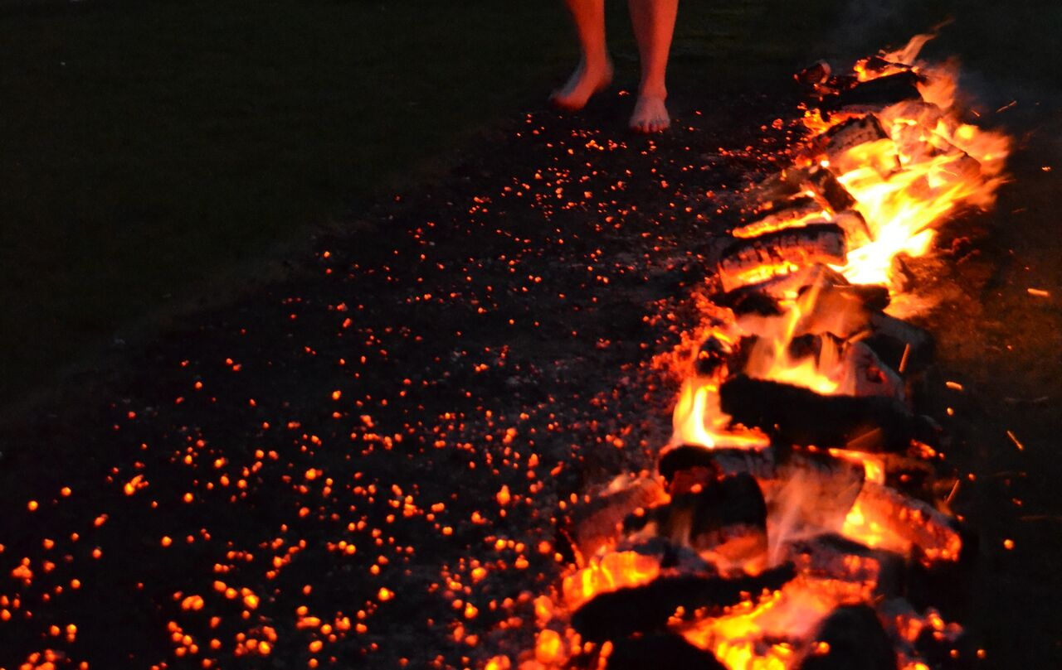

Join me and raise funds for
(insert your charity or cause name here)

I am mad but I am going to be taking part in the shortest, hottest and scariest walk of 2020. I will be walking across 1000 degrees hot coals all in the name of charity. Seventy per cent of sponsorship raised goes to (insert your charity or cause name here) and 30 per cent will go to children’s charity, the Kent Wish Foundation.

The firewalk takes place on Friday 15th March 2020 at the Broome Park Hotel in Canterbury. The Firewalk will take place right in front of the beautiful mansion.

If you can sponsor me please do so here (insert justgivingpage link)

You could also join up and raise funds for us too by registering at www.kentwish.co.uk

We will be trained by Scott Bell (Twice Guinness World Record holder for the greatest distance walked on fire) and then walk across hot coals with a temperature over 1000 degrees Fahrenheit!

It would be fantastic if you can take part by either sponsoring me or taking part yourself.

